Respiratory Sinus Arrhythmia & Heart Rate Variability
Background written by staff of ADInstruments with acknowledgement to Dr. Larry N. Reinking, Biology Department, Millersville University, Millersville, Pennsylvania, USA. Edited by Erica Wehrwein and Jamie Everett (5/2012) and Valerie VanRyn (1/2017).

Background
Respiratory Sinus Arrhythmia & Heart Rate Variability

Respiratory sinus arrhythmia (RSA) refers to the naturally-occurring synchronous fluctuations in heart rate that are linked to respiration. Heart rate increases during inspiration and decreases during expiration. The autonomic nervous system plays a major role in the interaction of the respiratory and cardiac systems as described below. RSA is an indicator of cardio-vagal tone and in enhanced with deep breathing. Thus deep breathing is a standard test in the suite of autonomic testing done clinically.

Slowly adapting lung stretch receptors, stimulated by the increasing tidal volume during inspiration contribute to this reflex. The signal about lung stretch is carried from stretch sensitive sensory nerve endings up centrally through vagal afferent fibers from the lung epithelial layer in the airways centrally to the medulla. From the medulla, the increased stretch signal is processed to cause vagal efferent nerve activity to the heart (cardiac) decreases markedly during inspiration (decreasing parasympathetic output to the SA node) allowing the heart rate to accelerate by eliminate the inhibitory effect of acetylcholine on the SA node. The opposite happens during expiration when pulmonary stretch signal is low and vagal efferent activity increases to slow heart rate. This reflex is known as the Hering-Breuer reflex (figure 1).
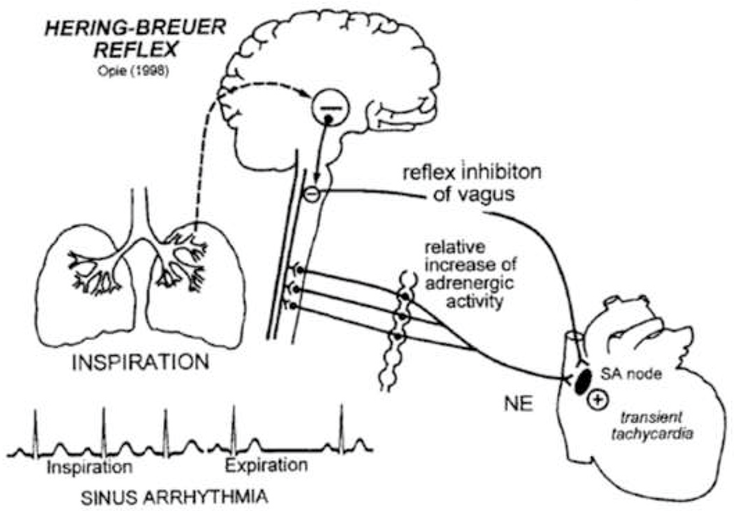

Figure 1: Hering-Breuer Reflex

RSA, a high frequency oscillation in heart rate, is one component of measure heart rate variability (HRV). HRV overall is how much the heart rate changes in normal day-to-day activity and is an indicator of the health of the nervous system. There is also a low frequency oscillation of heart rate that occurs over hours rather than seconds as does RSA. This low frequency is more related to sympathy and hormonal control. It is analyzed by comparing the time from one R-wave to the next (or one arterial pulse), over many beats. The fluctuation of the R-R interval (or beat to beat interval) is a characteristic of healthy individuals; the fluctuation is suppressed when people are stressed or have diseases, such as congestive heart failure. The same idea applies to a pulse trace, except there would be a change in the peak to peak interval rather than the R-R designation that only applies to ECG.

RSA can be observed on an electrocardiogram or on a pulse transducer trace (as we will use in this experiment). On an ECG, this phenomenon is seen as subtle changes in the R-R interval duration synchronized with respiration. R-R interval is typically shortened during inspiration (successive beats are faster and closer together) and lengthened during expiration (successive beats are slower and further apart) leading to a variety of R-R interval durations occurring over time. There are several ways to assess the “strength” of RSA: 1) observing the maximum and minimum heart rate that occurs over a 1 min period and calculating a “max minus min” to determine the range of rates observed (the higher the number, the more profound RSA is), 2) the standard deviation of the R-R interval durations (ms) tells us about the extent to which the heart rate varies (the higher the standard deviation the more different lengths of RR intervals exist and therefore a higher number means more varilabiltiy), and 3) more advanced calculations are done in research and clinical that involve assessment of spectral power. Standard deviation of the mean RR interval is called SDRR or SDNN (where “N” refers to a normal RR interval free of artifact or flaws in the recording). The table below shows normal values by age.
Table 1: Effects of aging on 24Hr heart rate variability (SDNN).

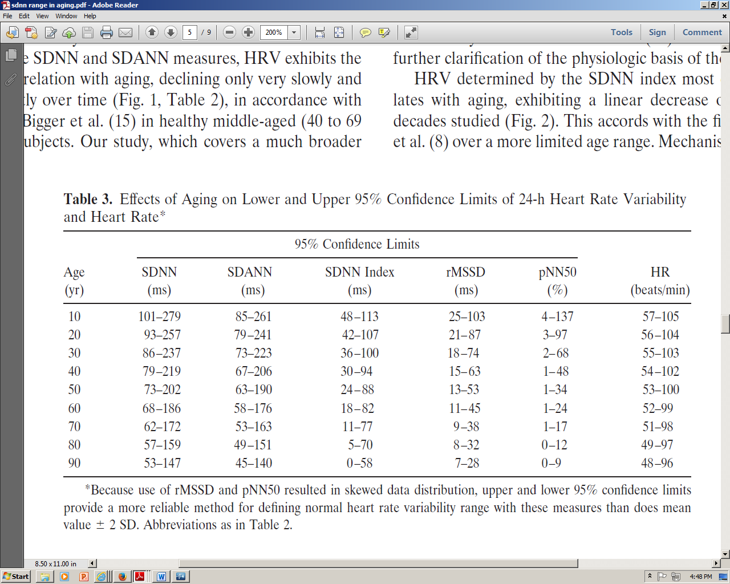

In humans, RSA becomes less prominent (as observed with lower SDNN) with age, diabetes, and cardiovascular disease. There are also differences in people of the same age group, particularly amongst athletes and non-athletes. Athletes, or people who exercise regularly, have a stronger RSA and greater heart rate variability than non-athletes or sedentary individuals. Other factors that can change RSA include: gender, body position, resistive breathing, tidal volume, deep breathing associated with meditation, and body mass index and obesity. It is possible to strengthen RSA through deep and slow breathing patterns developed using such techniques as yoga, meditation, and tai-chi.

Experimental Objective

Aims

1) To measure the variability of beat to beat intervals using pulse wave during normal and deep breathing by using PowerLab.

2) To become familiar with the PowerLab and Chart program.

In lab 2, Powerlab hardware, a finger pulse transducer, a respiratory belt and LabChart software will be used to record raw pulse data, cyclic measurements for heart rate (HR) data and raw respiratory data.

This week we will explore the complex interweaving natures of the autonomic nervous, cardiac and respiratory systems. A pulse transducer will be used this week to monitor heart rate while also using respiratory belt around the chest to observe how inspiration is linked to elevated heart rate and expiration is linked to reduced heart rate, or RSA. The Labchart software takes the peaks of the pulse waves and can calculate a beat to beat interval (ms) that is tightly aligned with the ECG RR interval since it is the cardiac electrical activity that drives heart contraction and thus pulse rate. Remember that heart rate is not a static measurement and each successive heart beat will have a slightly different beat to beat or RR interval. You will investigate how much your heart rate varies with respiration.

Important Notes:
- The respiratory belt is a Velcro strap that wraps around your chest or abdomen to monitor chest wall movements with breathing.
  - Some people are “chest breathers” and will get a good signal by wrapping the belt around the lower ribcage while others are “belly breathers” and will get better results by securing the belt below the diaphragm or at the navel. You can determine which position is best by sitting and breathing normally while one hand is on the navel and the other on the mid-rid-cage. Which regions to moving more with each breath? Put the belt on accordingly.
  - The strap should be snug but not too tight since the belt records data while it stretches and if it is on too tight it will not be able to stretch further with your breathing.
  - Finally, where the belt over the lowest layer of your clothing and not over a thick sweater/sweatshirt or other heavy clothing.
- The pressure pad of the pulse transducer is wrapped firmly around the distal portion of the finger in order to transmit a clear signal.
  - If the strap is excessively tight, the finger blood flow will be reduced causing a weak signal.
  - If it is too loose, the signal will be weak, intermittent or noisy.
  - If the finger is placed face down on the table with the pulse transducer between the finger and the table, the blood flow signal will be skewed because you are applying external pressure to the device.
  - If your hands are too cold you will have limited finger blood flow and the pulse transducer may not pick up the signal. You must warm the hands by running under warm water, rubbing the hands together, doing hard grip exercise, etc.
  - The protocol suggests using the middle finger, but if that does not work you can try the thumb.
  - It may help to drop the arm and hand to one’s side, rather than rest of the table if you are not getting a good signal. Gravity will enhance blood flow to the hand when it is lower than the heart.

